Final Design Documentation

# Requirements

The fermentor is to grow *E. coli* under constant temperature conditions while monitoring the cell color change, the overall density of the cells.

The following requirements were provided by the course instructors, and system specifications were developed to meet them:

1. Sustain a fluid medium of 150 – 200 mL, without leaking
2. Maintain an internal fluid medium temperature appropriate for growing *E. coli* (37 deg C +/- 1 deg C)
3. Enable controlled medium sampling and material introduction without interrupting operation
4. Provide adequate aeration of fluid medium (at least 100 mL per minute of air flow)
5. Provide adequate mixing/agitation of fluid medium without shearing the cells (mixing times <10 seconds, tip speeds <2m/s)
6. Measure optical density of the fluid, robust to variable ambient lighting conditions in the lab setting (e.g., sunlight and fluorescent lights), and record the value and current time at an appropriate rate to capture expected changes in optical density (or at least once per minute)
7. Measure how green the culture color is, robust to variable ambient lighting conditions within the laboratory setting (e.g., sunlight and fluorescent lights), and record the value and current time, at an appropriate rate to capture expected changes in culture color (or at least once per minute)
8. Interface with MATLAB/computer to provide real-time plots and data logging, and record timestamp, sensor data (e.g., temperature, color, optical density), and actuator control signal data (e.g., agitation, aeration, thermal element) for display and review
9. Has a start/stop button to control system operation

Additionally, we imposed the following requirement on our project:

1. Operate, monitor, and control the fermentor using a single-board computer that is not running MATLAB, and display live-updating information and plots about the fermentor onto a webpage.

# System-Level Specifications and Verification Test Results

Some specification numbers refer to subsystem specifications, hence gaps in numbering of the system-level specifications.

|  |  |  |  |  |  |
| --- | --- | --- | --- | --- | --- |
| Specification number | Specification Description | Test to perform | Relevant Requirement | Specification [units] | Measured Value [units] |
| 1.1 | Water volume | Measure dimensions | 1 | > 200 [mL] | 10 cm x 10 cm x 4 cm |
| 1.2 | Water Tightness | Perform dye tracing test when fermenter is filled with 200 mL of water, with leaked dye captured by paper towels around epoxy joints. Measure time until paper shows visible color. | 1 | > 1 hr | > 1 [week] |
| 2.8 | Fluid Temperature Regulation | Measure amount of time during which system can maintain a fluid medium temperature between 36C and 38C | 2 | > 1 hr | > 1 [hr] |
| 1.4 | Material Exchange | Measure the surface area available for medium sampling and material introduction while system is operating | 3 | > 4 [cm^2] | 10 x 10 [cm^2] |
| 2.9 | Aeration | Measure the aeration of fluid medium | 4 | ≥ 0.00353 CFM | 7 [ft^3/min] |
| 2.4 | Agitator Speed | Measure number of revolutions the impeller turns in 30 seconds at 0.15x speed in 200 mL of water | 5 | 5 to 58 [rev] | 47 [rev] |
| 2.5 | Mixing Time | Measure amount of time required to fully mix a drop of food coloring when motor is at 0.15x speed in 200 mL of water at 9V supply | 5 | < 66 [s] | 5 [s] |
| 3.12 | Ambient light robustness | Check difference between processed Arduino pin readings when the phototransistor is held at a constant distance and angle from a constant red LED and either the system is held under a box or not | 6,7 | ≤ ±5 | ±5 |
| 3.13 | Phototransistor Readings (Red LED) | Read pin values when phototransistor is illuminated through a light tube immersed in 2 cm of water gap by a red LED | 6,7 | > ~700 | 696 |
| 3.14 | Phototransistor Readings (Green LED) | Read pin values when phototransistor is illuminated through a light tube immersed in 2 cm of water gap by a red LED | 6,7 | > ~700 | 742 |

# System Block Diagram

# 

# Subsystem Design

## Circuit Schematics

### Actuators

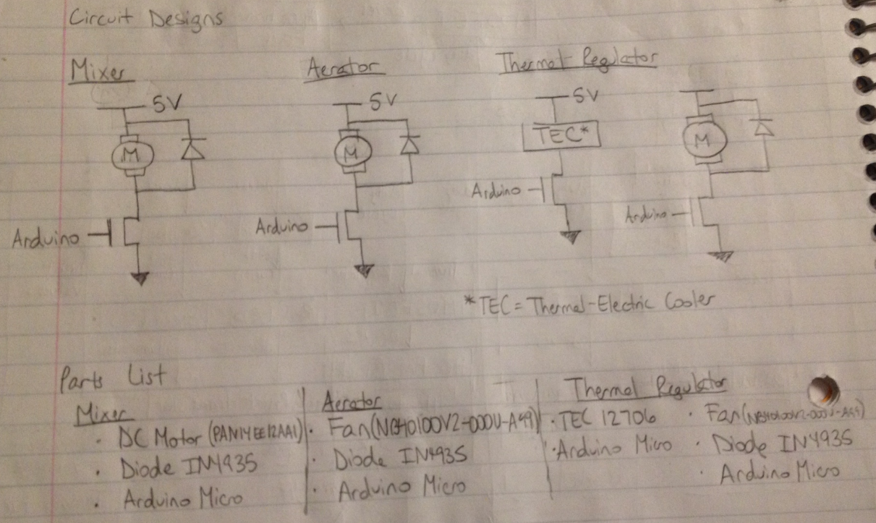

### Sensors

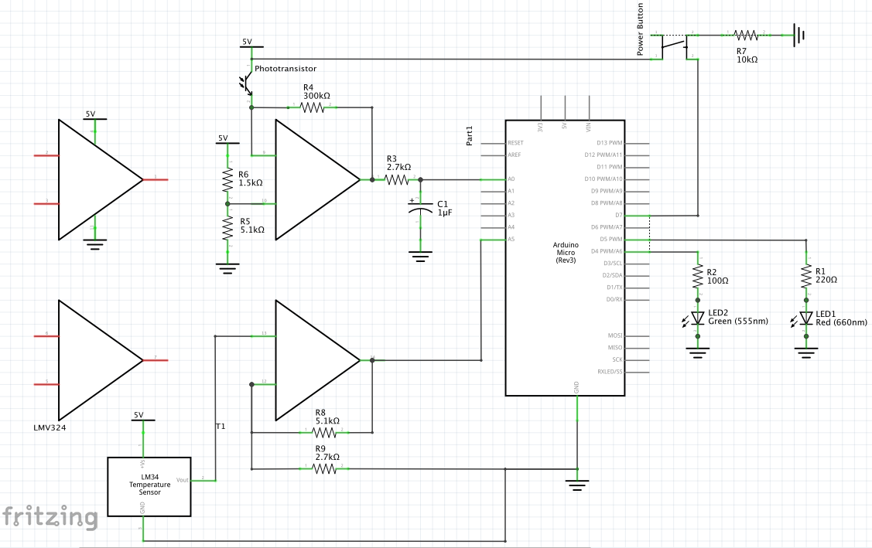

## Circuit Components

* Control
  + Arduino Micro
  + Raspberry Pi B+
* Mixer
  + IRF520 nMOS transistor
  + DC Motor (PAN14EE12AA1)
  + Diode IN4935
* Thermal Regulation
  + IRF520 nMOS transistor
  + TEC 12706 thermoelectric cooler
* Temperature Sensing
  + LM34
  + LMV324
  + 2.7 kΩ and 5.1 kΩ resistors
* Power Button
  + Tactile switch
  + 10 kΩ resistor
* Optical Sensing
  + Green LED
  + Red LED
  + 100 Ω, 220 Ω, 1.5 kΩ, 2.7 kΩ, and 5.1 kΩ resistors
  + 1 μF capacitor
  + LMV324
  + Phototransistor
* Ventilation
  + IRF520 nMOS transistor
  + Fan (NB40100V2-000U-A99)
  + Diode IN4935

## Mechanical Designs

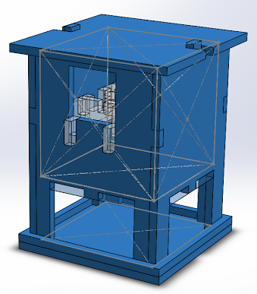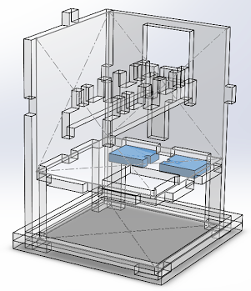

Left: outer framework

Right: mounting plates for LEDs, which are to be pointed upwards

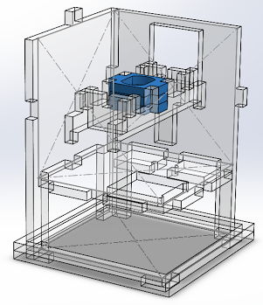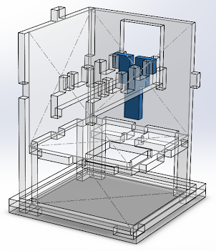

Left: mounting plates for motor

Right: mounting plate/light tube for phototransistor

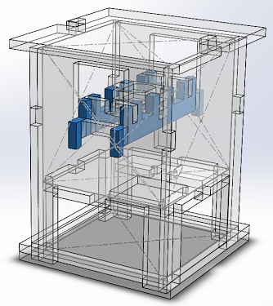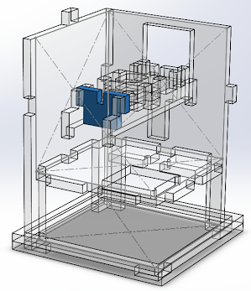

Left: mounting plate support rails

Right: mounting plate for temperature sensor

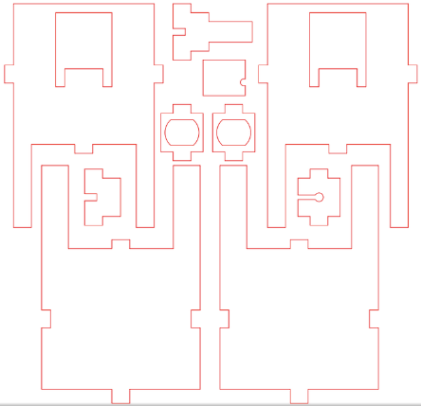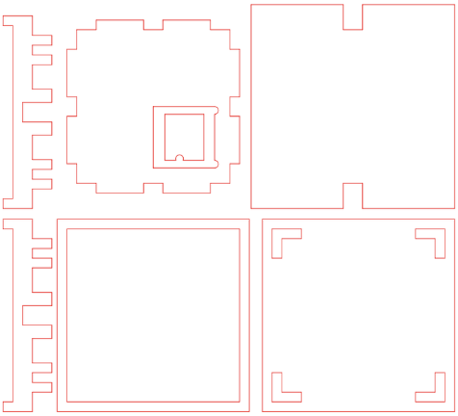

Acrylic sheet cutting layouts (two 12”x12”x0.25” sheets)

## Build Notes

Initial breadboard layout:

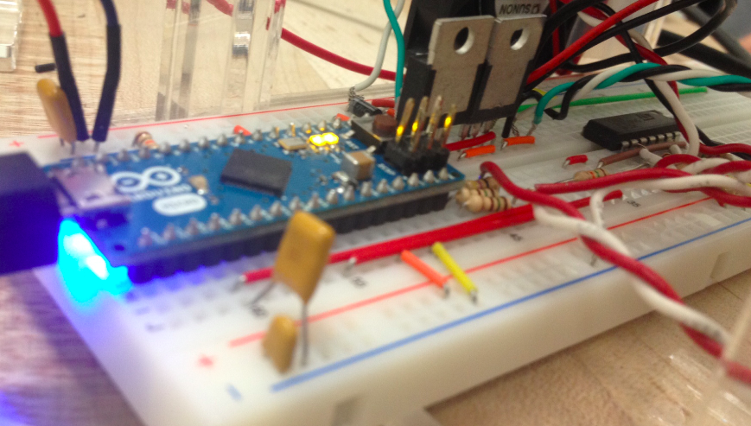 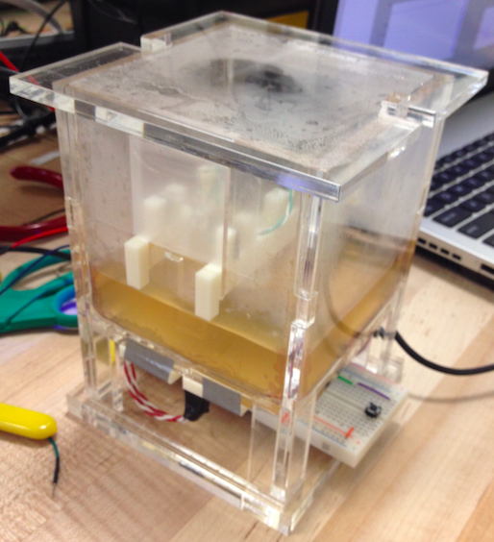

The twisted group of green, red, and black wire in the above image leads to a MOSFET mounted on the heatsink that is epoxied to the TEC. The heatsink cools the MOSFET, which would otherwise get extremely hot from driving the TEC.

The LED mounting plates are duct taped to the vessel.

## Breadboard layout optimization

The following is a compacted version of the breadboard layout shown on the previous page, with the MOSFET for the TEC mounted directly onto the heatsink of the TEC, rather than sitting on the breadboard:

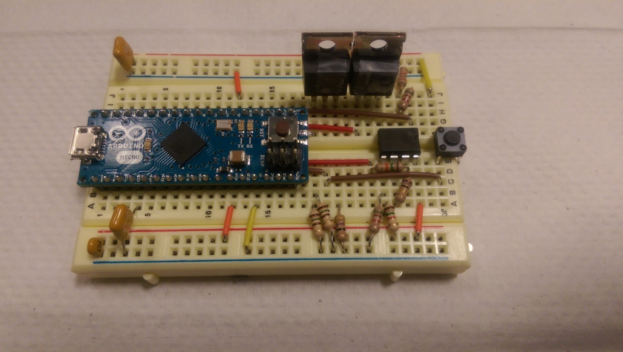

When all off-breadboard components are plugged in, this layout will have four free rows; all other rows will be used.

# Subsystem Specifications and Unit & Integration Test Results

|  |  |  |  |  |  |
| --- | --- | --- | --- | --- | --- |
| Specification number | Specification description | Test to perform | Relevant requirement | Specification [units] | Measured value [units] |
| 1.1 | Water volume | Measure dimensions | 1 | > 200 [mL] | 10 cm x 10 cm x 4 cm |
| 1.2 | Water tightness | Perform dye tracing test, with leaked dye captured by paper towels around epoxy joints. Measure time until paper shows visible color. | 1 | > 1 [h] | > 1 [h] |
| 1.3 | Clearance underneath vessel | Measure height of vessel base above tabletop | 2 | > 4 [cm] | 5.3 [cm] |
| 1.4 | Material exchange | Measure cross-sectional area of an opening in the vessel that can be accessed while system is operational | 3 | > 4 [cm2] | 10 x 10 [cm2] |
| 2.1 | Aerator current | Measure current through circuit when fan is running for 20 min | 1, 2 | 0.9 [μA] to 180 [mA] | ~130 [mA] |
| 2.2 | Agitator current | Measure current through circuit when motor is running at full speed in water | 3 | > 0 [mA] | 260 [mA] |
| 2.3 | Agitator stall current | Measure current through circuit when motor is stalled for 20 min | 4 | > 0 [mA] | ~ 250 [mA] |
| 2.4 | Agitator speed | Measure number of revolutions the impeller turns in 30 seconds at 0.15x speed in water | 5 | 5 to 58 [rev] | 47 [rev] |
| 2.5 | Mixing time | Measure time until water homogeneity after addition of a drop of food coloring at a vessel corner when motor is at 0.15x speed | 6 | < 66 [s] | 5 [s] |
| 2.6 | Thermal regulator current | Measure current through circuit when heater is running at full duty cycle for 200 mL of water for 20 min with 5 V supply. | 7 | ~ 2.28 [A] | 250 [mA] |
| 2.7 | Thermal regulator responsiveness | Measure time required to heat 200 mL of water from room temperature up to 37 °C with 9 V supply. | 8 | < 30 [min] | 23 [min] |
| 3.1 | OD measurement rate | Measure the minimum rate at which OD measurements are taken | 1 | > 1 [min­-1] | 0.67 [s-1] |
| 3.2 | Greenness measurement rate | Measure the rate at which greenness measurements are taken | 2 | > 1 [min­-1] | 0.67 [min-1] |
| 3.3 | Light normalization measurement | Check whether measurements are normalized to ambient light | 1, 2 | Yes | Yes |
| 3.5 | 60 Hz noise attenuation | Measure gain of a 60 Hz green LED flickering superimposed on a DC red LED illumination | 1,2 | < 0.75 | ~0.5 |
| 3.6 | Light dynamic range minimum | Check unprocessed Arduino pin reading when the phototransistor is completely blocked | 1,2 | ~770-780 | 765 |
| 3.7 | Ceiling light sensitivity | Check difference between unprocessed Arduino pin readings when the phototransistor is completely blocked and when the phototransistor is pointed upwards at/under a ceiling light | 1,2 | < 100 | ~60 |
| 3.8 | Downwards ceiling light sensitivity | Check difference between unprocessed Arduino pin readings when the phototransistor is completely blocked and when the phototransistor is pointed downwards away from a ceiling light | 1,2 | <50 | 0 |
| 3.9 | Red light dynamic range maximum | Check processed Arduino pin reading when the phototransistor is illuminated by a red LED across a 2 cm air gap between the LED and the phototransistor | 1 | > 700 | 750 |
| 3.10 | Green light dynamic range maximum | Check processed Arduino pin reading when the phototransistor is illuminated by a green LED across a 2 cm air gap between the LED and the phototransistor | 2 | > 700 | 750 |
| 3.11 | Measurement consistency | Check variation across processed Arduino pin readings when the phototransistor is held at a constant distance and angle from a constant red LED | 1,2 | ≤ ±5 | ±1 |
| 3.12 | Ambient light robustness | Check difference between processed Arduino pin readings when the phototransistor is held at a constant distance and angle from a constant red LED and either the system is held under a box or not | 1,2 | ≤ ±5 | ± 5 |
| 4.1 | MOSFET reliability | Use oscilloscope to measure duty cycle of MOSFET driven by the Arduino at 50% duty cycle | 2 | 50% | 50% |
| 4.2 | Maximum fluid temperature | Drive TEC at 100% duty cycle heating 200 mL of initially-room-temperature water and check whether fluid can be heated to 38 °C | 2 | Yes | Yes |
| 4.3 | Fluid response time (heating) | Measure time required to heat (100% duty cycle TEC) 200 mL of stirred fluid (25% duty cycle motor) from 36 °C to 38 °C | 2 | < 20 [min] | 5 [min] |
| 4.4 | Fluid response time (cooling) | Measure time required to cool (0% duty cycle TEC) 200 mL of stirred fluid (25% duty cycle motor) from 38 °C to 36 °C | 2 | < 20 [min] | 3 [min] |
| 4.5 | LM34 calibration (lower) | Measure steady-state voltage of LM34 output when immersed in 26 °C fluid | 2 | ~ 0.716 [V] | 0.26 [V] (pin value 145) |
| 4.6 | LM34 calibration (upper) | Measure steady-state voltage of LM34 output when immersed in 38 °C fluid | 2 | ~ 1 [V] | 0.38 [V] (pin value 214) |
| 4.7 | Amplifier gain | Measure gain of amplifier circuit | 2 | ~ 2.89 | 2.85 |